Connected Educator Lesson Planning Template
Lesson Title:
Grade and Curriculum Areas:

Curricular Outcome(s):

Resources /Materials:

Websites and Digital Resources:

Lesson Creator:

Peer Reviewer of Lesson:

Check off the boxes that pertain to your lesson.

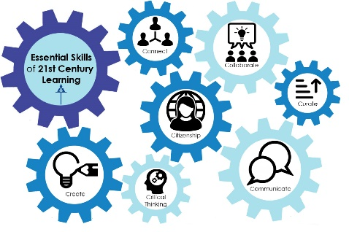
Essential Skills of 21st Century Learning:
☐ Create
☐ Critical Thinking
☐ Collaborate
☐ Communicate
☐ Connect
☐ Curate
☐ Citizenship

Digital Citizenship Continuum:

Respect
☐ Digital Etiquette: The electronic standards of conduct or procedure
☐ Digital Access: Full electronic participation in society
☐ Digital Law: The electronic responsibility for actions and deeds

Educate
☐ Digital Communication: The electronic exchange of information
☐ Digital Literacy: The capability to use technology and knowing when and how to use it
☐ Digital Commerce: The electronic buying and selling of goods

Protect
☐ Digital Rights and Responsibilities: The privileges and freedoms extended to all digital technology users and the behavioural expectations that go with them
☐ Digital Safety and Security: The electronic precautions that all technology users must take to guarantee their personal safety and the security of their network
☐ Digital Health and Wellness: The physical and psychological well-being related to digital technology use

Lesson Essential Question(s):

Before:

During:

After:

Assessment:
Please include any rubrics, checklists or digital tools used in the assessment of student learning.
☐ Assessment for Learning ☐ Assessment as Learning ☐ Assessment of Learning

