Coding In The Math Classroom
Dean Vendramin
Coding has been an important part of the technology revolution since its inception, but now more than ever it is becoming an important skill for students to understand and be familiar with. I have read many an article on Twitter that coding is a vital 21st Century Skill and that it has many tie ins to a math class. This research (this site in particular had a great infographic to help make it easy to see the impact of coding - http://www.lifehack.org/articles/lifestyle/5-unbeatable-reasons-your-kid-should-coding.html) and my understanding of future employable skills have convinced me that I need to look at ways of incorporating coding into my classroom.
Coding itself has been around for a while. I still remember getting a good old Commodore 64 (probably dating myself here). I remember figuring out the code to display a stick man and using the ‘GOTO’ command to make that poor old stick make do an infinite amount of jumping jacks. This wasn’t much but even the skills I learned way back in the day served me well and the concept of programming lends itself to many of the same thought process needed in mathematical computation. After all that’s basically what a computer does is take the commands and executes the math behind them at tremendous speeds.
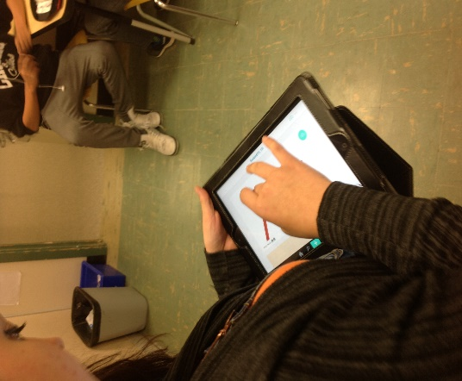
Although there are Computer Science offerings at many of the schools I am familiar with, this is not the case in many places around the world and the enrollments are not necessarily high and the enrollments I have seen definitely didn’t have a high number of female students. I know there are many organizations out there such as Code.org and Ladies Learning Code that are out there trying to change these trends and have coding become more available, accessible, and all-inclusive. It is easy to see that there are many trends pointing towards traditional jobs becoming obsolete and the workforce of the near future is and will continue to change. Much of the evidence I have explored points to coding and the skill sets that come with this to become very valuable in the future (and not just for making stick men do jumping jacks).
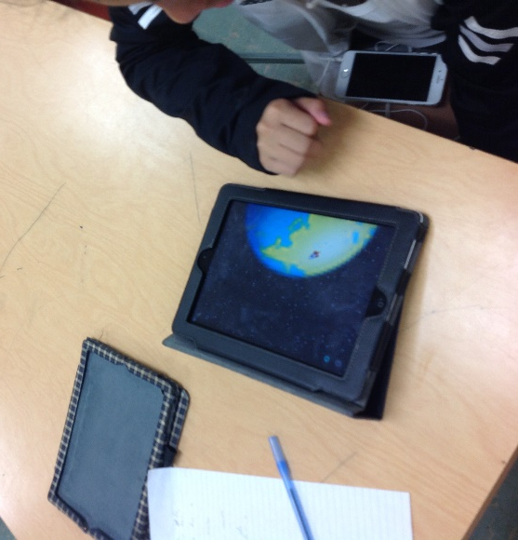
The integration of code into a math class makes a lot of sense in many ways. It is important to understand the rules that govern both, be able to sequence, model, and problem solve, and see the creativity that can be accomplished with both. Both require the mindset that ‘I can do this’ and remove the fear factor that becomes obstacles in many people’s minds for both. Students need to develop grit and rigor to accomplish what they set out for in both and see mistakes as an opportunity to grow and learn from. The joy of solving problems and creating new learnings and understandings are available for students in both math and coding. Coding can have one advantage though as seeing something you have constructed work (like a jumping stick man) can be a little more motivating and gratifying that factoring a trinomial. That being said students should be introduced to the beauty of these disciplines, acquire an appreciation of what both have to offer there understanding of the world around them and realize that these skills will serve them well in the future.
So last year I decided that I needed to start somewhere with bringing coding into my classroom. The first opportunity that I decided to pursue was to participate in The Hour of Code that is a promotion of coding through out the world sponsored by Code.org. This movement’s goal is to get as many students world-wide coding for at least one hour over the course of a week. I jumped on board and had students in my class hop on an app called Hopscotch (free on the Apple App Store) and follow the built in tutorials and make games like Crossy Roads, Geometry Dash, and Flappy Bird. The following semester I took it to another level and included coding as an option in my Genius Hour (time given to students to pursue projects they are interested in and given class time for see – geniushour.com for more information on this classroom strategy) projects that I had my grade 9 math students working on. With both projects I attempted, I had what I felt were positive results as students were engaged, experimenting, problem solving, and having fun . I particularly enjoyed the Genius Hour projects as the students that choose coding had more time to explore and ‘work’ through their own ideas. My next goal is to make coding a part of my daily bell work for the grade 9 math classes I have (I will have access to my own set of laptops as I am part of a connected educator program that my division is offering). I’m looking forward to new adventures, learnings, and outcomes that will come with this.
Does one need a computer science background to get involved in this? The answer is No! The Hopscotch App that I used with the iPads we have was all ‘block based’. This means that you don’t have to know a coding language you just drag the blocks with the words on them and as one student suggested ‘it is kinda like making a sentence’. The commands are all set up and all one has to do is put the ‘sentence’ together and then play the code to see if your ‘sentence’ had the proper sequence, conditions, or logic to work the way you intended it to work. If it didn’t you needed to go back to your code and try to figure out what rule or syntax you need to change to get the desired effect. It is definitely about understanding the process, identifying the patterns, and using the tools you have to create … a lot like you do in math class.
I also liked the other math concepts that are embedded into coding especially using an app like Hopscotch. Understanding big ideas such as understanding how each little block works will lead to creating big projects, computers speak numbers and you have to tell them what to do, that there are a variety of ways to look at and solve problems, and the process of iteration. More specific math concepts such as understanding the stage that the characters are coded onto use the first quadrant of the Cartesian Plane and students must understand how x and y coordinates and slope work. An activity like this can help introduce students to linear equations in grade 9 math. Students also need to examine concepts like angles, random numbers, conditions, and even physics as they code pre-set instructions or venture off with their own creations.
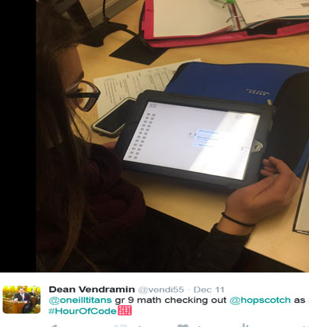
My students especially at a grade nine level enjoyed the simplicity and structure of using the Hopscotch App. It had the ability to engage both reluctant and first time coders but also enough power to challenge those who were looking for more. The tutorials and ability to make games they see on the app store was appreciated and it was cool to see some students take their learning in a different direction. There are many other block coding apps out there such as Scratch, Scratch Jr, Blocky Block that offer similar experiences. Both Microsoft (Touch Develop) and Apple (Swift) are offering free coding software for people to get into code.
I have been pleased with the results that adding coding to my math class has produced. I am excited to take this integration to another level and see where it takes me and my students. I’m not a computer programmer by any means and my limited programming prowess although useful has not been a necessary part of this journey. I have also come across ‘paper’ programming where students put together code block cut out from paper to understand and work through the coding process (http://www.fractuslearning.com/2014/11/18/coding-with-paper-printable-game/). I also believe that this can be and should be done K through 12. As with other ideas, I encourage those to research, find a good starting place, and go for it. I feel that you and your students will be glad you did. I hope to continue to gain new understandings and share what I find with others. If you have questions or suggestions contact me at d.vendramin@rcsd.ca or find me on twitter @vendi55.
Dean Vendramin has had a variety of teaching experiences over his 19-year teaching career. Currently, he is a Math/Science Education Lead at Archbishop M.C. O’Neill Catholic High School in Regina, Saskatchewan. He is passionate about technology integration and assessment practices. Dean has been recognized for his work throughout his career, having received among other awards a Certificate of Achievement from Prime Minister’s Teaching Excellence Awards and an Innovative Math Teacher Award from the Saskatchewan Math Teachers’ Society, and has been recognized by a number of technology companies for his work in integrating technology in the classroom. He is passionate about improving his craft, sharing ideas, and supporting the needs of those he serves. Contact Dean at d.vendramin@rcsd.ca, follow him on Twitter at @vendi55, or check out his blog and eportfolio at deanvendramin.weebly.com.

