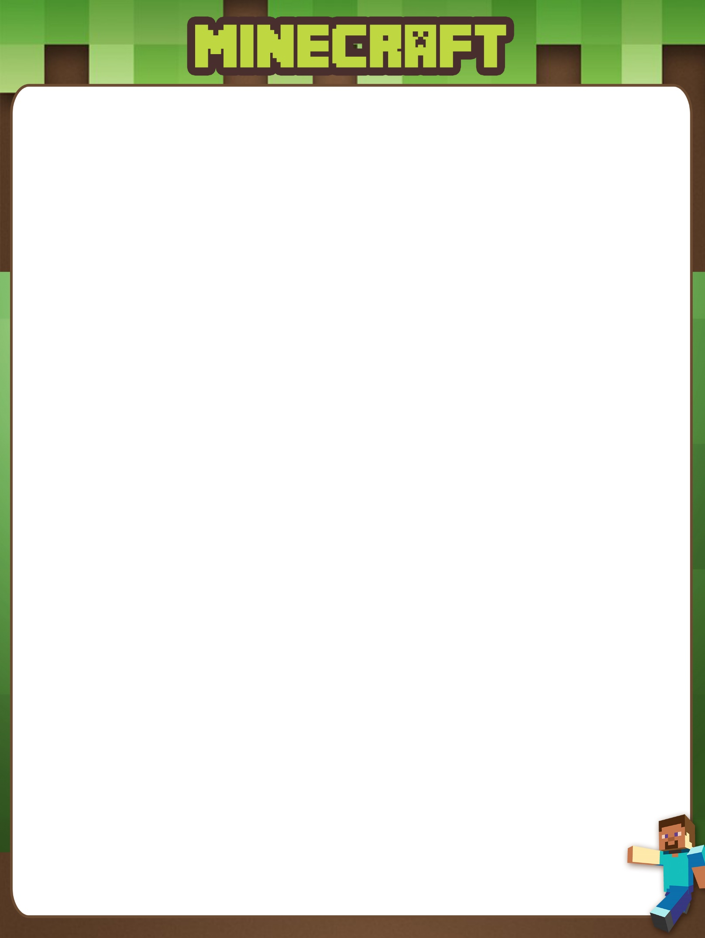

Notes



Battle Build #2 – 50m2

Battle Build #3 – Symmetry

Battle Build #1 – 25m2